Conn hr/hr

Exercise Chapter 5

DBMS A

1. Find the highest, lowest, sum, and average salary of all employees. Label the columns  
   as Maximum, Minimum, Sum, and Average, respectively. Round your results to the nearest whole number. Save your SQL statement as lab_05_04.sql. Run the query.

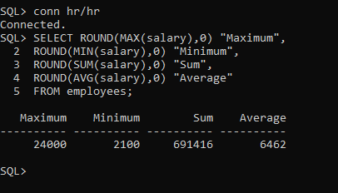

1. Modify the query in lab_05_04.sql to display the minimum, maximum, sum, and average salary for each job type. Resave lab_05_04.sql as lab_05_05.sql. Run the statement in lab_05_05.sql.

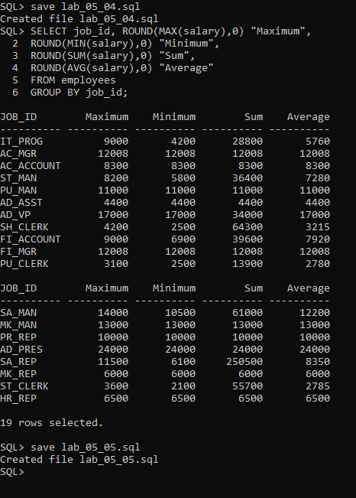

1. **Write a query to display the number of people with the same job.**

Generalize the query so that the user in the HR department is prompted for a job title. Save the script to a file named lab_05_06.sql. Run the query. Enter IT_PROG when prompted.

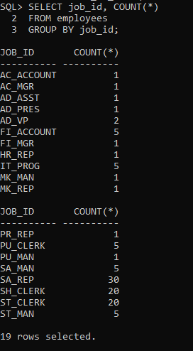 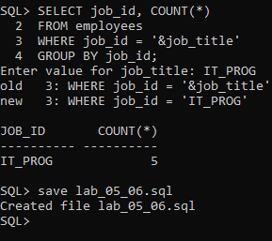

1. Determine the number of managers without listing them. Label the column as Number of Managers. *Hint: Use the MANAGER_ID column to determine the number of managers.*

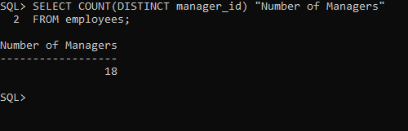

1. Find the difference between the highest and lowest salaries. Label the column DIFFERENCE.

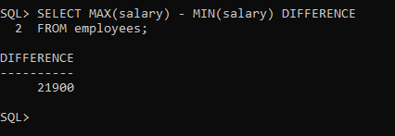

1. Create a report to display the manager number and the salary of the lowest-paid employee for that manager. Exclude anyone whose manager is not known. Exclude any groups where the minimum salary is $6,000 or less. Sort the output in descending order of salary.

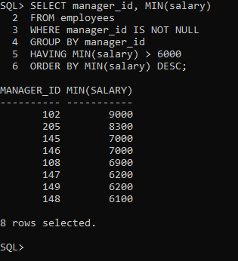

1. Create a query to display the total number of employees and, of that total, the number of employees hired in 1995, 1996, 1997, and 1998. Create appropriate column headings.

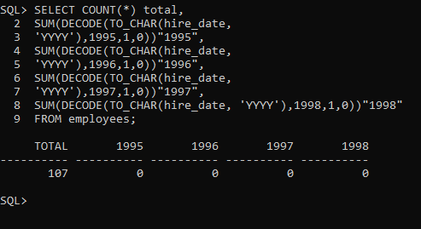

1. Create a matrix query to display the job, the salary for that job based on department number, and the total salary for that job, for departments 20, 50, 80, and 90, giving each column an appropriate heading.

